State Machine Lab

General

This is a practical example of how to use software design patterns in modeling real-world embedded systems applications.
By illustrating how to apply design patterns during development of a garage door controller, we demonstrate the important benefits of state design patterns:
- Software Modularity
- Code Re-usability
- Improved Maintainability
- Lower Costs
- Faster Time-to-Market

Practical - A Garage Door Controller

Controller Specifications
Most modern garage doors have a button to toggle the door up and down. If the door is down and the button is pushed, the door will start to open. If the door is open and the button is pushed, the door will start to close. It should also be possible for the user to reverse the direction of the door by pressing the button while the door is moving (four-year-olds love to perform this operation repeatedly to the annoyance of their parents!).
Furthermore, if the door reaches its final position (either at the top or bottom), the controller should signal the motor to stop driving the door. Most garage doors also have a sensor beam located at the bottom of the door. In the event that someone or something stands directly underneath the door while it is closing, the door should open back up to prevent a collision and possible bodily injury.
Controller Design
There are, of course, ultimately many ways one could choose to design the garage door controller. For most engineers, an intuitive solution involves using a state machine to govern the behavior of the garage door under the various situations described. Two obvious states are “OPEN” and “CLOSED,” and these indicate the status of the garage door under the stationary conditions implied by their names.
A third state is needed to describe the motion of the garage door. It would be tempting to call this state “MOVING”, but such a state cannot capture which direction the door is moving. Among other reasons, it would be important to know this information to determine whether tripping the sensor would require any action as described above. Thus, it is necessary to utilize two states to describe the garage door motion. These will be called “OPENING” and “CLOSING.” The final state machine is shown below:
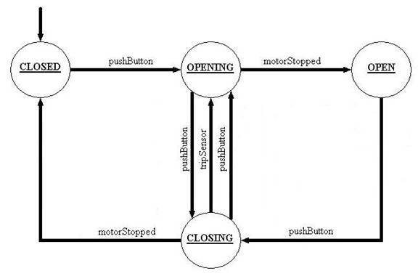
Figure 1: Garage Door State Machine
The transition labeled ‘tripSensor’ is included as a safety feature to prevent objects or people from being crushed by a closing garage door. The transition ‘motorStopped’ indicates the door cannot travel any further in the direction it is moving, and has signaled the motor to stop driving it. The transition ‘pushButton’ is analogous to a human user pushing their garage door opener button to either open or close their garage door.
This is an overly simplistic view of a garage door controller.
The safety feature for tripping the sensor is attractive to those with children or people who have a tendency to leave things directly underneath the door (especially their cars)!
But what happens when power is lost and the door is ajar?
There is no state here to model error conditions such as lost power, nor is there any recovery mechanism. Since there are alternative design methods for handling the loss of power that do not involve the use of a state machine (i.e. flagging diagnostics), a solution for handling the loss of power in this design is intentionally omitted.
Transitioning the Controller from Design to Software
At this point, many embedded software engineers would code up a standard state machine solution. Enumerated constants would be used to designate the states. Additionally, a new thread would be spawned off that executed in a forever repeating loop. This loop would wait for events, and then take action on the event based on which state is current. The code for this state machine would like this:
#define STATE_OPEN 1
#define STATE_CLOSED 2
#define STATE_OPENING 3
#define STATE_CLOSING 4
#define EVENT_MOTORSTOPPED 1
#define EVENT_PUSHBUTTON 2
#define EVENT_TRIPSENSOR 3
int state = STATE_CLOSED;
// This code runs forever looking for events!
StateMachine::void run() {
GarageDoorControllerEvent newEvent;
while( 1 == 1 ) {
dequeueEvent( &newEvent );
switch( newEvent->getType() ) {
case EVENT_MOTORSTOPPED:
if( state == OPENING ) { state = OPEN; }
else if( state == CLOSING ) { state = CLOSED; }
break;
case EVENT_PUSHBUTTON:
if( state == CLOSED ) { state = OPENING; }
else if( state == OPEN ) { state = CLOSING; }
else if( state == CLOSING ) { state = OPENING; }
else if( state == OPENING ) { state = CLOSING; }
break;
case EVENT_TRIPSENSOR:
if( state == CLOSING ) { state = OPENING; }
break;
default:
// Not a valid event, either discard or flag an error?!
break;
}
// Don’t be a CPU hog, share with others and let them have a chance!
sleep( 50 );
}
}
NOTE: The above code omits details regarding threading, mutual exclusion for access of the state variable, and queuing mechanism for the stored events.
This method of straightforward coding, however, has some significant drawbacks. The change or addition of any events and/or transitions is cumbersome and rather error prone. Re-testing is required for this since the code has to change.

Assignments:
- Design a class diagram using the Design Pattern Called 'State'
Steps:
  - Each transition in the state machine design becomes a method in the abstract State class, and the implementation of each transition is placed inside the overridden concrete subclass methods.
  - Applying the above description to our garage door opener state machine design yields an abstract class GarageDoorControllerState with the three abstract methods pushButton, tripSensor, and motorStopped.
It also yields four subclasses of the GarageDoorControllerState called Closed, Closing, Open, and Opening.
  - The context object is largely template-driven and simply created for simplicity of usage
- Using the StateChart C++ starter project Implement the above class diagram.
NOTE: Don't forget to deal with the memory allocation issue while changing states.
- Run the program using the existing Test and find out if it's working logically.

